**Assignment 3 Template**

**LAST NAME: Lawson**

**FIRST NAME: John**

**USERID: jd2lawso**

**UWaterloo ID: 20466075**

**Problem 2: Fill in the information below based on your data which were generated using your ID number as the seed for the random number generator.**

**n = 20 theta = 5**

**The first 10 approximate 95% confidence intervals are:**

**[,1] [,2]**

**[1,] 3.535812 9.053183**

**[2,] 3.934067 10.072884**

**[3,] 2.428600 6.218248**

**[4,] 2.343656 6.000756**

**[5,] 2.523774 6.461935**

**[6,] 3.173387 8.125220**

**[7,] 3.177203 8.134991**

**[8,] 3.499099 8.959180**

**[9,] 3.247867 8.315919**

**[10,] 2.239389 5.733789**

**Do all 10 intervals contain only values greater than 0? YES/NO**

**Yes**

**Depending on the value of theta is it possible that some intervals will not contain only values greater than 0? Why or why not?**

**Yes because 5% of the intervals in a 95% confidence interval may be wrong.**

**The proportion of approximate 95% confidence intervals which contain the true value of theta = 0.927**

**How close is this proportion to 0.95? What are the reasons for this?**

This differs by about 2%, a small but noticeable amount, due to the small sample size

**The first ten 15% likelihood intervals (approximate 95% likelihood intervals) are:**

**[,1] [,2]**

**[1,] 4.193622 10.067219**

**[2,] 4.665969 11.201143**

**[3,] 2.880421 6.914727**

**[4,] 2.779675 6.672873**

**[5,] 2.993302 7.185711**

**[6,] 3.763770 9.035310**

**[7,] 3.768297 9.046176**

**[8,] 4.150078 9.962687**

**[9,] 3.852106 9.247371**

**[10,] 2.656010 6.376001**

**Do all your 10 intervals only contain values greater than 0? YES/NO**

**Yes**

**Depending on the value of theta is it possible that some likelihood intervals will not contain only values greater than 0? Why or why not?**

**Yes, because the 15% likelihood interval of the sample chosen may be offset by the sample chosen.**

**The proportion of 15% likelihood intervals which contain the true value of theta = 0.945**

**How close is this proportion to 0.95? What are the reasons for this?**

**This differs by about 0.5, since likelihood intervals are a better method for estimating likely bounds for parameter theta than confidence intervals when the sample size is small.**

**Insert the plot of the sampling distribution of the likelihood ratio statistic for n=20 here.**

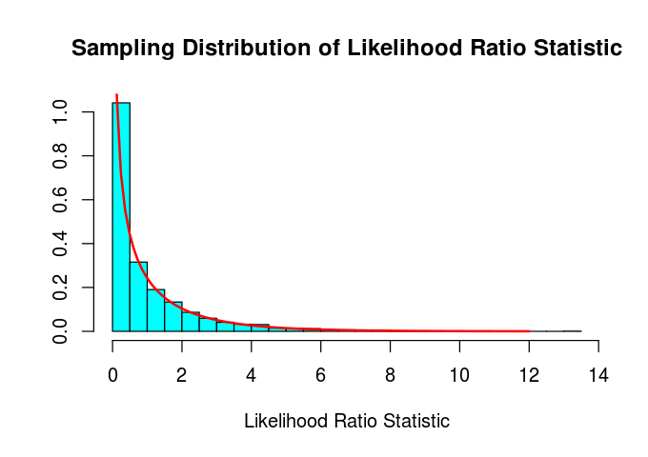

**For Exponential data the likelihood ratio statistic is a discrete or continuous random variable?**

**Continuous R.V.**

**How well does the Chi-squared(1) probability density function agree with the sampling distribution of the likelihood ratio statistic as approximate by the relative frequency histogram?**

**The fit between the Chi-square probability density function and the likelihood ratio is very good.**